14.Write a program to convert Decimal number to Hexadecimal number using any high level language.

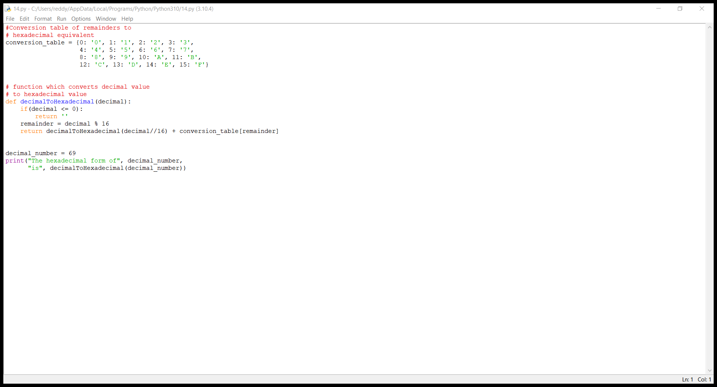

15.binato octol to 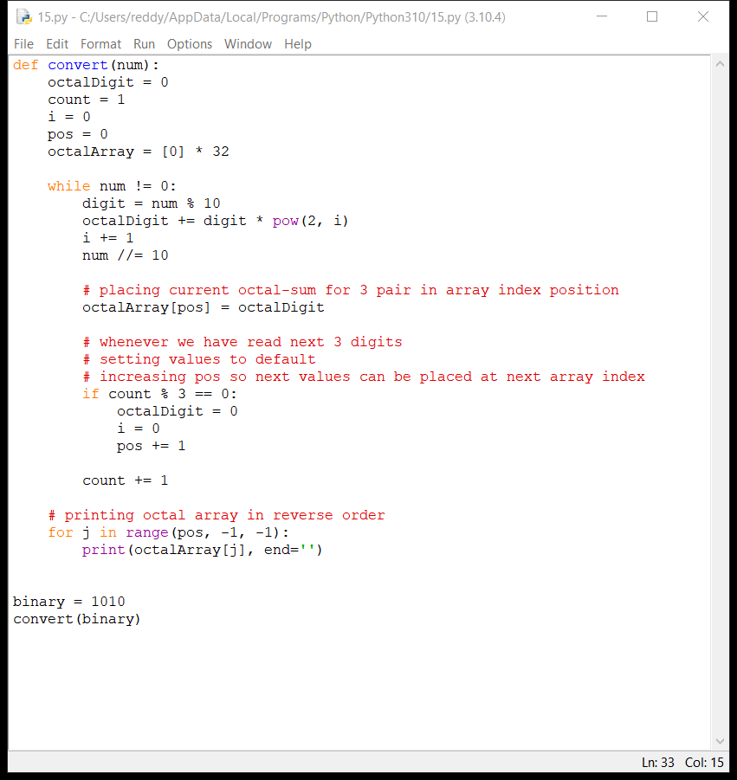

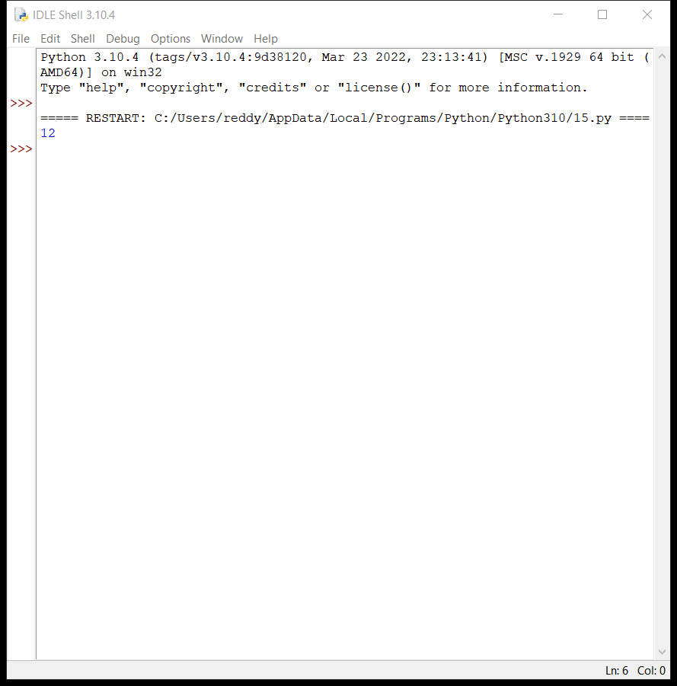

1. Write a program to convert Binary to Hexadecimal number to number using any high level language.

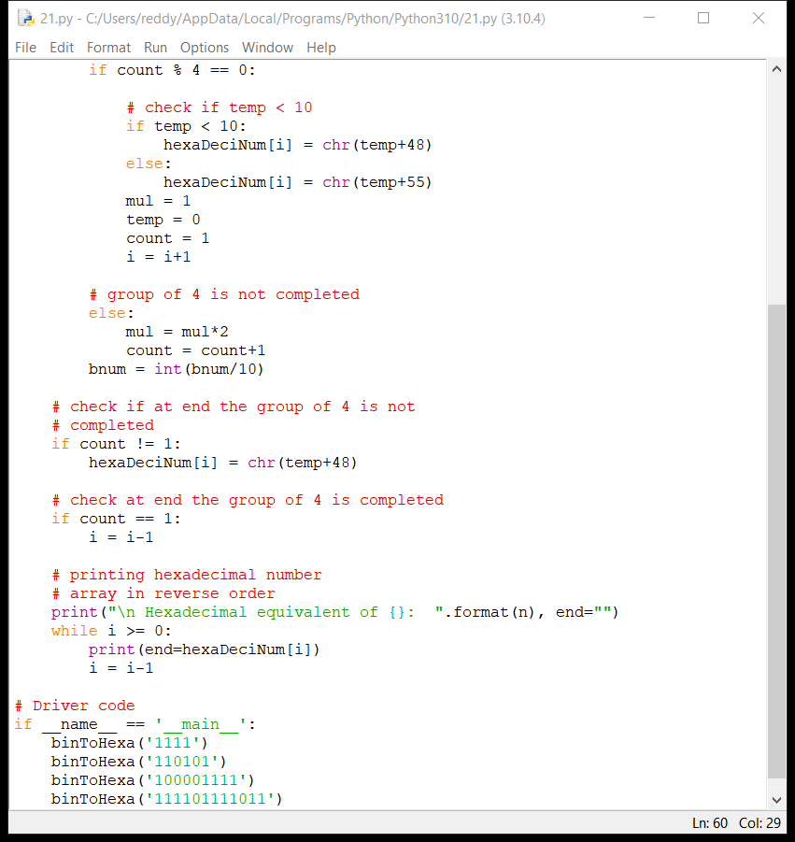

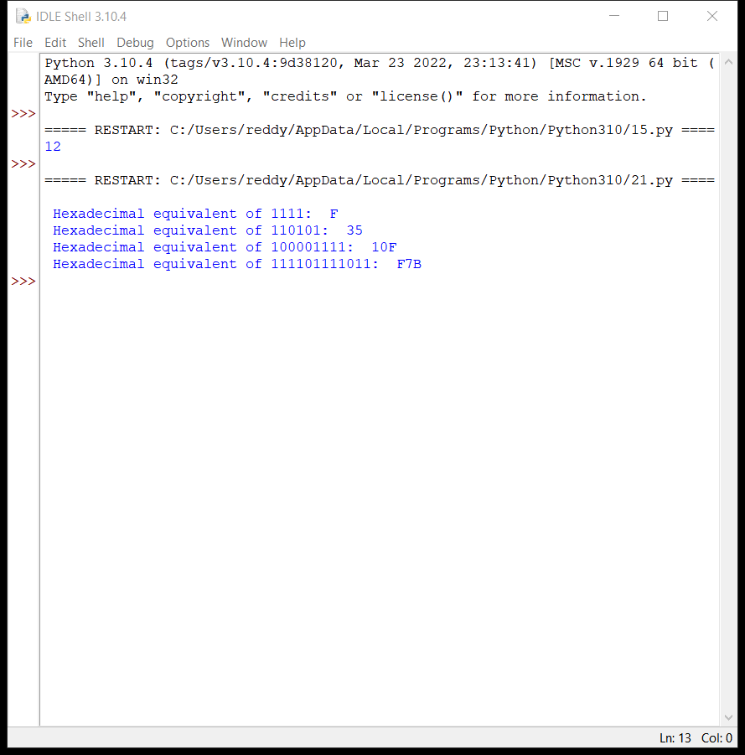

Design of 2 stage pipeline for addition of two numbers using any high level language

1. Write an assembly language program for adding two 16-bit datausing 8086 processor.

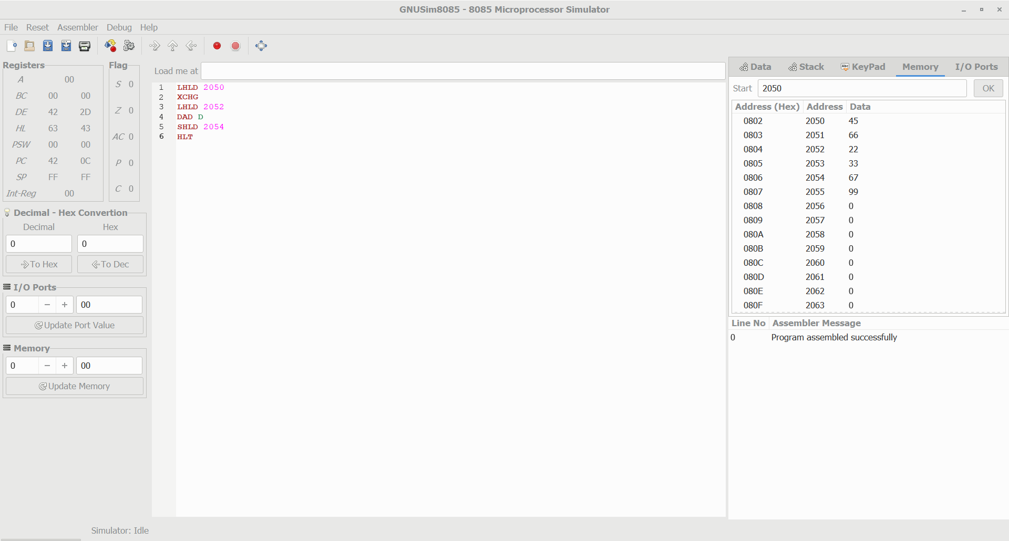

1. Write an assembly language program for subtracting two 16-bit datausing 8086 processor.
2. 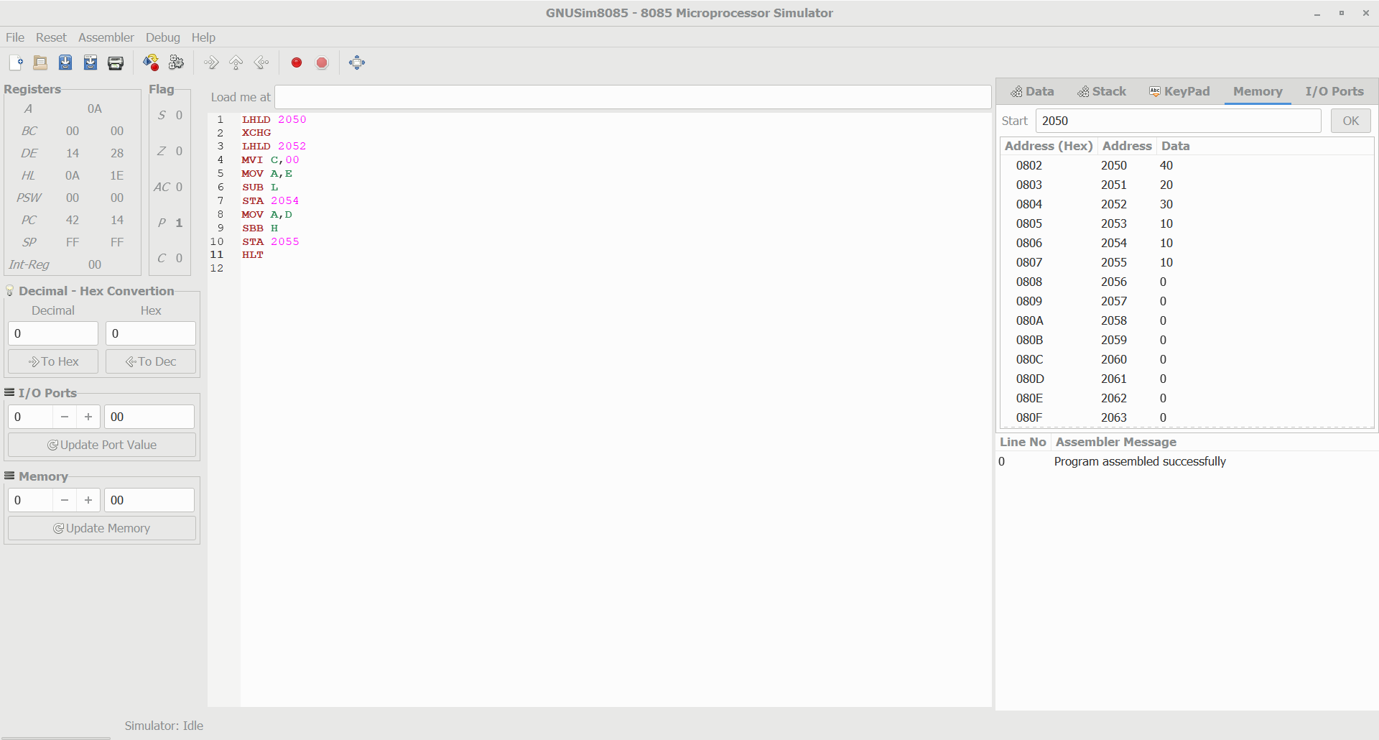

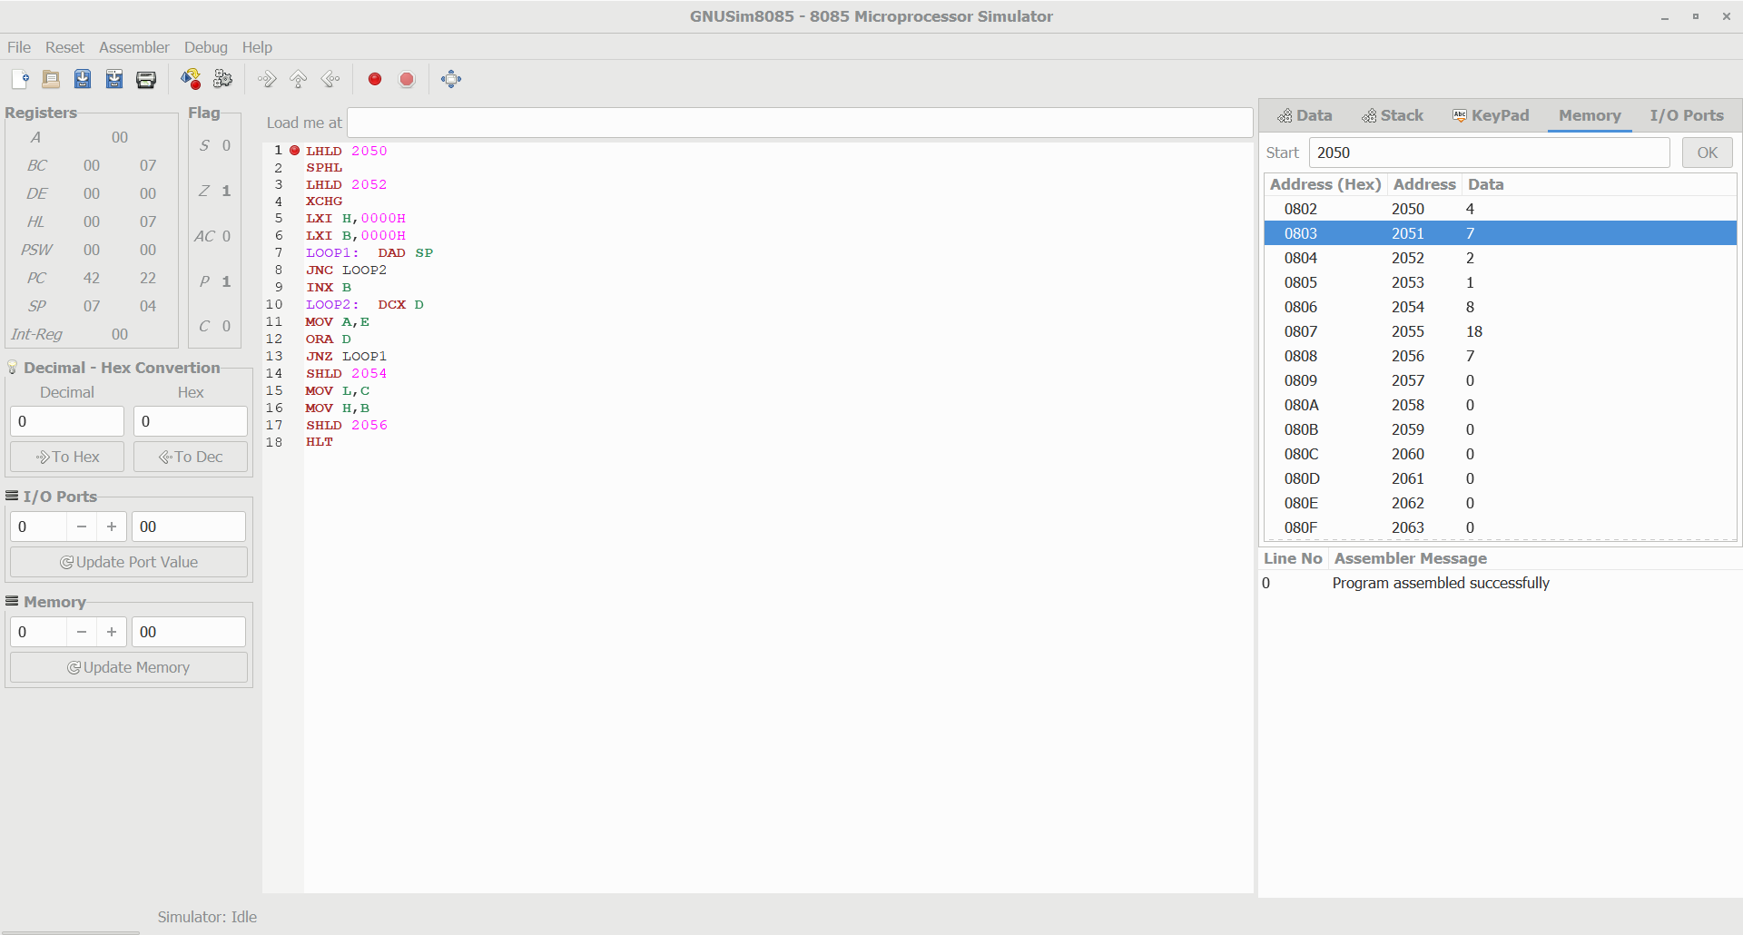

Design of 2 stage pipeline for addition of two numbers using any high level language.

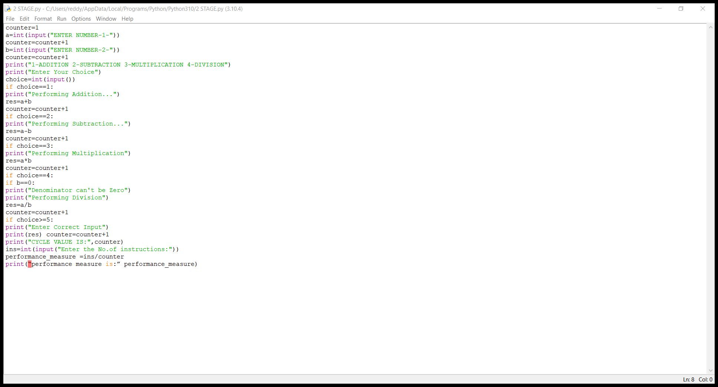

Design of 3 stage pipeline for AND of two numbers using any high level language.

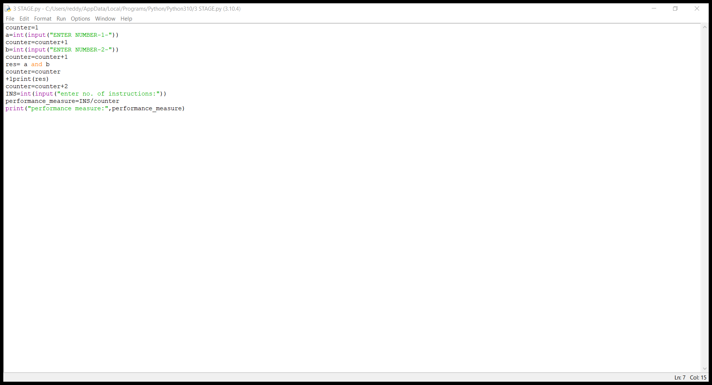

Design of 3 stage pipeline for OR of two numbers using any high level language.

FULL ADDER

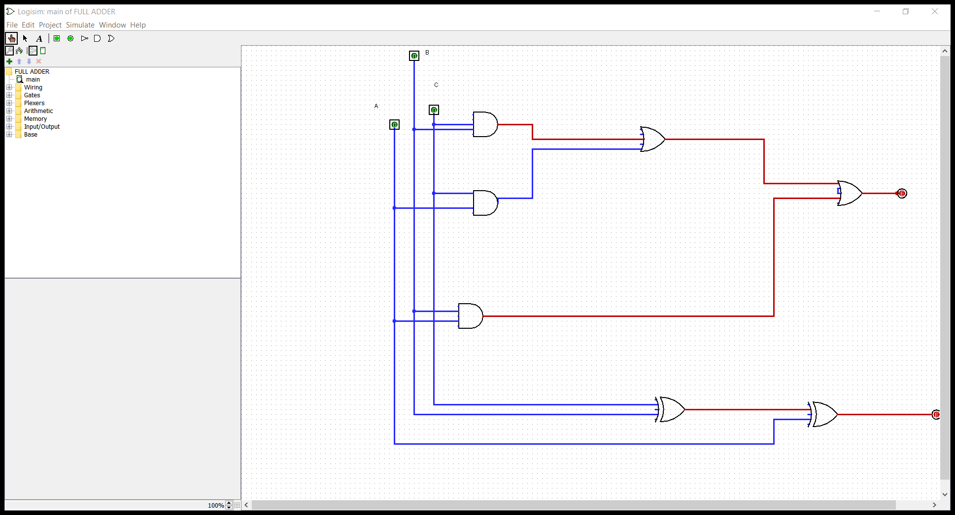

HALF ADDER AND SUBTRACTOR

